Parasheet Sprint #2 Plan 2025-07-15

Goal:

Write the bulk of the interpreter and finish the last bit of prior tasks.

Task Listing:

* User Stories
  + Save to file (1 SP)
    - Task: CSV Serialization
  + Load CSV (3 SP)
    - Task: CSV Parsing
  + Display Spreadsheet (3 SP)
    - Task: ncurses renderer
  + Execute a single cell (8 SP)
    - Task: Write Tokenizer
    - Task: Write AST Data Structure
    - Task: Write Parser
    - Task: Write Evaluator
    - Task: Write String Interning
    - Task: Write Symbol Table
* Infrastructure
  + Testing Framework
    - Add test file building to makefile
    - Write Test Runner Program

Team Roles:  
Clara Ceerla - Product Owner

Elijah Hantman - Developer

Allex Smith - Developer

Quincy Strange - Scrum Master

Eric Weng - Developer

Initial task assignment:

Clara Ceerla - ncurses renderer

Elijah Hantman - Write AST Data Structure

Allex Smith - CSV Serialization

Quincy Strange - Add test file building to makefile

Eric Weng - CSV Parsing

Initial burnup chart:

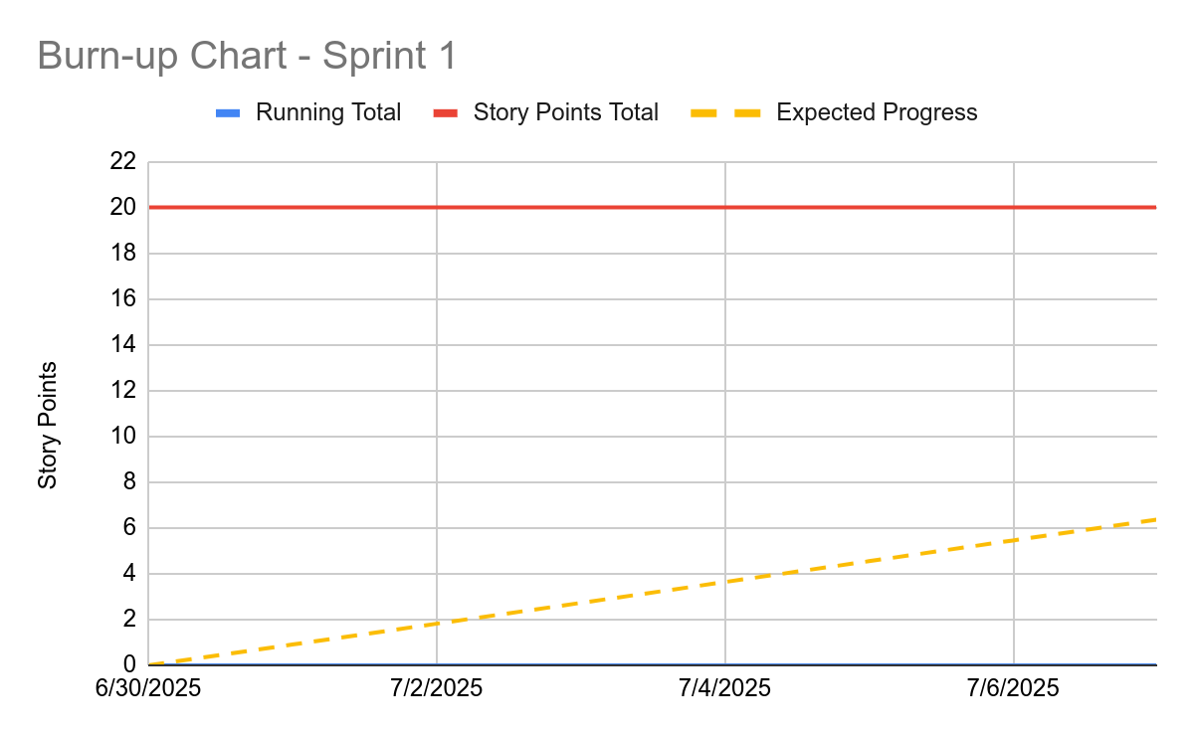

Initial scrum board:

| Available | In Progress | Under Review | Complete |
| --- | --- | --- | --- |
| Write Tokenizer  Write AST Data Structure  Write Parser  Write Evaluator  Write String Interning  Write Symbol Table  Write Test Runner Program | ncurses renderer (Clara) Write AST Data Structure (Elijah) CSV Serialization (Allex) Add test file building to makefile (Quincy) CSV Parsing (Eric) |  |  |

Scrum times:

5:15 PM Wednesday

1:20 PM Friday